BioShield
Designed by Maureen Gilmour and Eric Nickel
Business Plan by Sujan Doshi, Guy Frankam, Maureen Gilmour, Saad Shahab, and Ran Zhang
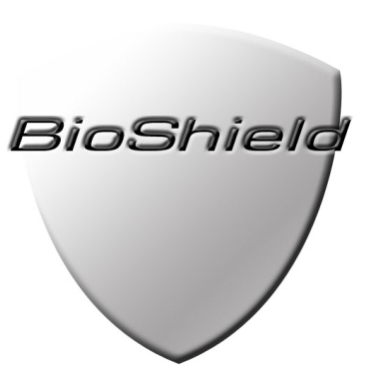

BioShield is a novel bulletproof vest design that provides optimal protection from National Institute of Justice Level III-V ballistic rounds, while offering flexibility for the user’s movement during combat.

Our technology uses existing materials arranged in a novel way to create the optimal vest for soldiers and law enforcement personnel. The various sized plates protect the user by taking into account the varying body structure present in the torso. For hard, inflexible areas such as the rib cage, larger plates are used to guarantee that the vest does not deform. The deformation of the vest in this area would endanger the life of the wearer, because any deformation of the rib cage results in a potentially punctured vital organ. For soft, flexible areas such as the stomach, smaller plates will be used to allow for slight deformation and greater flexibility. We do not move our upper torso as much as our lower torso, and because the stomach area conveniently can deform more than the upper torso, so can the vest to allow optimal movement and equal protection.

The vest is comprised of a cross section of stiff, inflexible, small plates backed by a slightly flexible metal, surrounded by a polyurethane elastomer. The entire vest is encased in Kevlar Aramid Fibre, adding extra protection and stab resistance.

Our vest can take four or five hits, as opposed to one or two, because unlike ceramic, the Young’s Modulus of titanium beta alloy and tungsten carbide is high, making them stiff but fairly flexible materials. Their material properties allow the small plates encased in polyurethane inside the vest to come together on impact and encase the bullet.

Below is a drawing of a cross section of our vest:

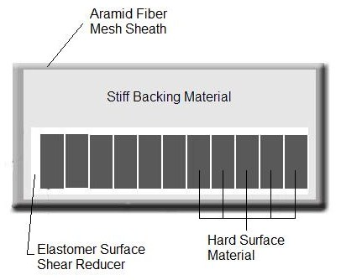
Figure 1. Vest before impact

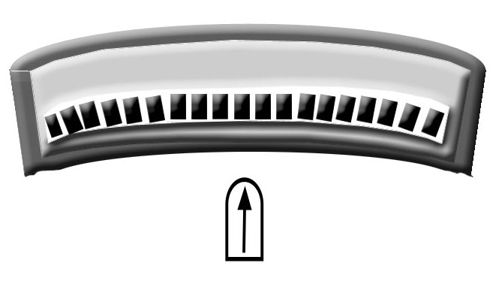
Figure 2. Vest during impact

As the material encases the bullet, the bullet is deformed significantly and cannot pass through the other side of the vest.
Our vest’s price is comparable to other inferior vests on the market, making it a competitive product.
Our business venture is versatile because our product includes the ability to remove the stiff plates, making the vest a Level III. Level III is the optimal level for many SWAT teams and law enforcement personnel.
We hope to obtain a patent for this technology, secure funding for further testing with the Department of Defense, and construct a prototype to be tested in a National Institute of Justice certified facility.

